THRESHOLDING
Bijali Jayalakshmi Jayan

Thresholding
Thresholding is a type of image segmentation, where we change the pixels of an image to make image easier to analyse .
In thresholding, we convert an image from colour or grayscale into a binary image, that is, one that is simply black and white.
In Digital Image Processing, is the simplest method of segmenting image.
From a grayscale image, thresholding can be used to create binary image.
- Thresholding is the simplest segmentation method.
- The pixels are partitioned depending on their intensity values.
- The Gray levels of pixels belonging to the object are entirely different from Gray levels of pixels belonging to the background in many application of image processing.
- Thresholding becomes then a simple but effective tool to separate those foreground objects from background.
- We can divide the pixels in the image in to 2 major groups, according to their Gray level.
- These Gray levels may serve as “detectors” to distinguish between background and objects is considering as foreground in image.
- Select a Gray level between those 2 major Gray level groups, which will serve as a threshold to distinguish the 2 groups (objects and background).
The simplest property that pixels in a region can share is intensity. So, a natural way to segment such regions is through thresholding, the separation of light and dark regions. Thresholding creates binary images from grey level ones by turning all pixels below some threshold to zero and all pixels about that threshold to one. A threshold image g(x,y) is defined as:
g(x,y)=1,if f(x,y)<T
=0, if f(x,y)<T
Where 1 is object and 0 is background.

Intensity based thresholding
- The intensity values are different in different regions.
- Within each region, which represents the corresponding object in a scene, the intensity value are similar.
Image thresholding classifies pixels into 2 categories:
Those to which some property measured from the image falls below a threshold, and those at which the property equals or exceeds a threshold.

Simple Thresholding
In simple thresholding, all pixels values those are greater than the specific threshold values, assign to standard value. It compares pixel values with special threshold values. After segmenting the pixel, we can see the segmented images according to threshold values. Threshold techniques are mainly divided into 3 categories based on the threshold operator.
Global: threshold operator depends on the Gray values of the pixel.
Local: threshold operator depends on the grey values of pixel and local properties.
Dynamic: threshold operator depends on the grey values of the pixel and local properties and it’s position.

Global Thresholding
In fixed (or global) thresholding, the threshold value is held constant throughout the image.
Using an appropriate threshold T:
g(x,y)= 1, if f(x,y)>T
0, if f(x,y)<=T

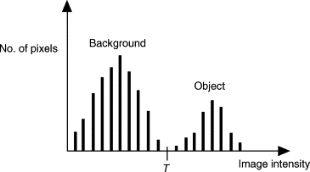
Global thresholding is based on the assumption that the image has a bimodal histogram and, therefore, the object can be extracted from the background by a simple operation that compares image values with a threshold value T.
T is constant applicable over whole image.

Variable Thresholding
If T can change over the image.
Local or regional thresholding- if T depends on a neighbourhood of (x,y).
Adaptive thresholding-if T is a function of (x,y).
Dynamic(adaptive)thresholding- T depends on spatial coordinates (x,y).

Multiple Thresholding

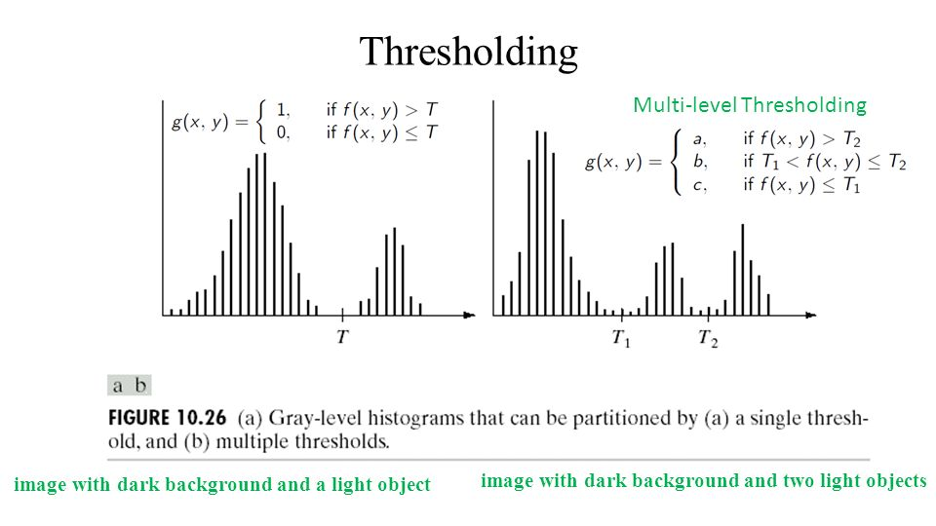
peaks and valleys of image histogram can help in choosing the appropriate value for the thresholds.
Segmentation requiring more than 2 thresholds is very difficult and variable thresholding or region is growing is often preferred.

Some factors affects the suitability of the histogram for guiding the choice of the threshold:
- Separation between peaks.
- Noise content in image.
- Relative size of object and background.
- Uniformity of illumination.
- Uniformity of reflectance.

Noise Role in Thresholding

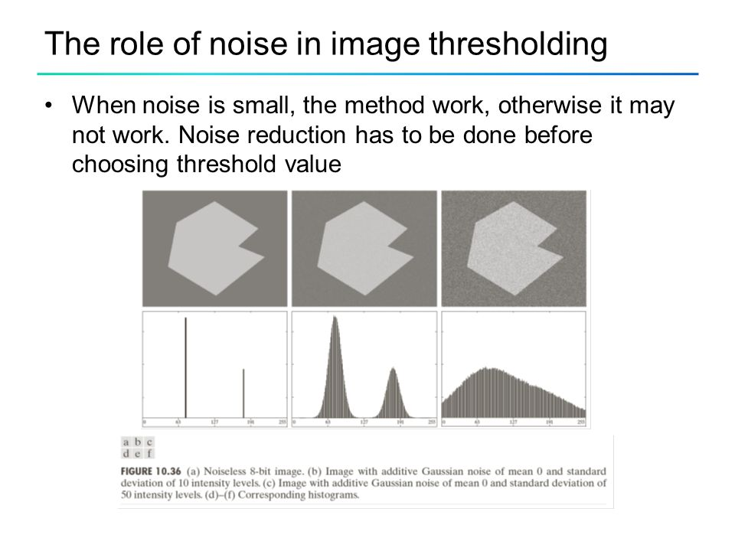

Illumination and reflection role
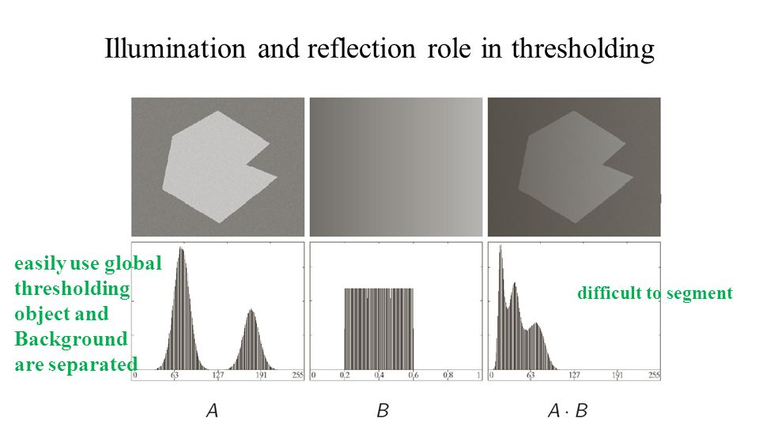

Optimum Global Thresholding using OTSU’s Method
- OTSU’s method is aimed in finding the optimal value for the global threshold.
- It is based on interclass variance maximization.
- Well threshold classes have well discriminated intensity values.
- M x N image histogram:
- L intensity levels [0,…….,L-1]
- ni #pixels of intensity, i
$$MN=\sum_{i=0}^{L-1}{ni}$$
- Normalized histogram:
Pi=ni/MN
$\sum_{i=0}^{L-1}{Pi=1}$
$$where Pi≥0$$
- Using k,0<k<L-1, as threshold, T=k
- 2 classes:
- C1(Pixels in[0,k]) &
C2(Pixels in[k+1,L-1])
- P1=p(C1)= $\sum_{i=0}^{k}{Pi}$, Probability of class C1
- P2=p(C2)= $\sum_{i=k+1}^{L-1}{Pi}$ = 1-Pi, Probability of class C2
- M1, mean intensity of pixels in C1:

m1=$\sum_{i=0}^{k}{i.P(i|C1)}$
=$\sum_{i=0}^{k}{iP\left(C1\backslash i\right)P(i)/P(C1)}$
=1/P1. $\sum_{i=0}^{k}{i.Pi}$
Where P(C1|i)=1
P(i)=Pi
P(C1)=P1
- Similarly, m2, mean intensity of pixels in C2:
m2= 1/P2$\sum_{i=k+1}^{L-1}{i.Pi}$
- Mean global intensity, mG:
mG=$\sum_{i=0}^{L-1}{i.Pi}$
- While the mean intensity up to the k level, m:
m=$\sum_{i=0}^{k}{i.Pi}$
- Hence:
P1m1+P2m2=mG
P1+P2=1
- The global variance σ2G:
σ2G=$\sum_{i=0}^{L-1}{\left(i-mG\right)2.Pi}$
- The between class variance, σB can be defined as:
σ2B=P1(m1-mG)2+P2(m2-mG)2
P1P2(m1-m2)2
(mGP1-m)2/P1(1-P1)x
- The goodness of the choice T=k can be estimated as the ratio, ͷ:
ͷ= σ2B/ σ2G
- The quantities required for the computation of ͷ can b obtained from the histogram
- Hence, for each value of k, ͷ(k) can be computed:
ͷ(k)= σ2B(k)/ σ2G
where σ2B(k)=(mGP1(k)-m(k))2/P1(k)(1-P1(k))
- The optimal threshold value, k*, satisfies:-
σ2B(k*)=max0<k<L-1 σ2B(k)

